Vaibhav Chaudhari & Ben Allen

IST 664

Professor Hoyos

12 December 2022

Final Project Report

**Data:**

For our project, we used three separate data sources to evaluate several factors related to song, artist, and overall music popularity. A json file of Spotify top charts, a csv file of artist streaming statistics, and another csv file containing adjacent artist and song information were all used to perform data analysis on our research question.

The json file (spotify_songs_data) contains the top 2000 songs from 2000-2019 with descriptive elements like key, danceability, energy, acoustics, genre, etc. in addition to a ranked year by year list with song and artist names. In addition to simply evaluating these song ranks during each year in this time period, these data can be used to gauge the music characteristics most often associated with the Spotify top charts, if we are to perform correlation analysis.

The artist streaming csv (artist_stat) contains statistical information like streams, features, tracks, and number of songs that have passed 1 billion / 100 million streams. Building upon the data from the previous section, this data can be used to contextualize the ranked charts by allowing us to visualize artist popularity over time through several raw streaming measures.

The additional csv (artist_spotify) contains a few key measures, namely followers, popularity score (scale 1-100), and genre, each of which was used in conjunction with the artist streaming data to provide a clear picture of the popularity of artists and song genres during our time period.

These data were used to investigate a different piece of analysis, regarding the popularity of artists, songs, and music characteristics that have dominated the music market over the past 20 years. Several pre-processing steps were necessary upon loading in our files to clean the data in preparation for analysis.

**Pre-processing:**

***Process 1: Dropping abnormal rows***

*Dataset: artist_stat*

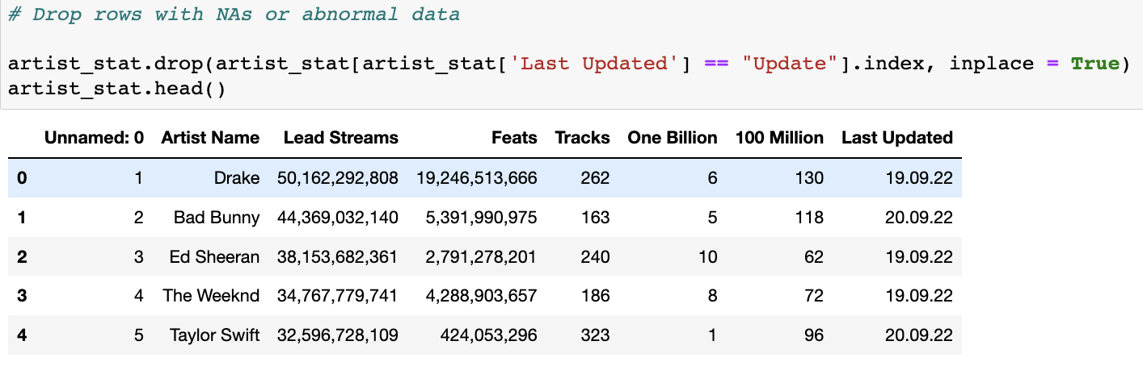

*Reasoning:*

After reading in the artist_stat data, we noticed the “Last Updated” column had some null / irregular values in place of the supposed data for which the streaming number were most recently measured. To avoid confusion, we dropped these missing rows by filtering out by index.

***Process 2: Changing data types***

*Dataset: artist_stat*

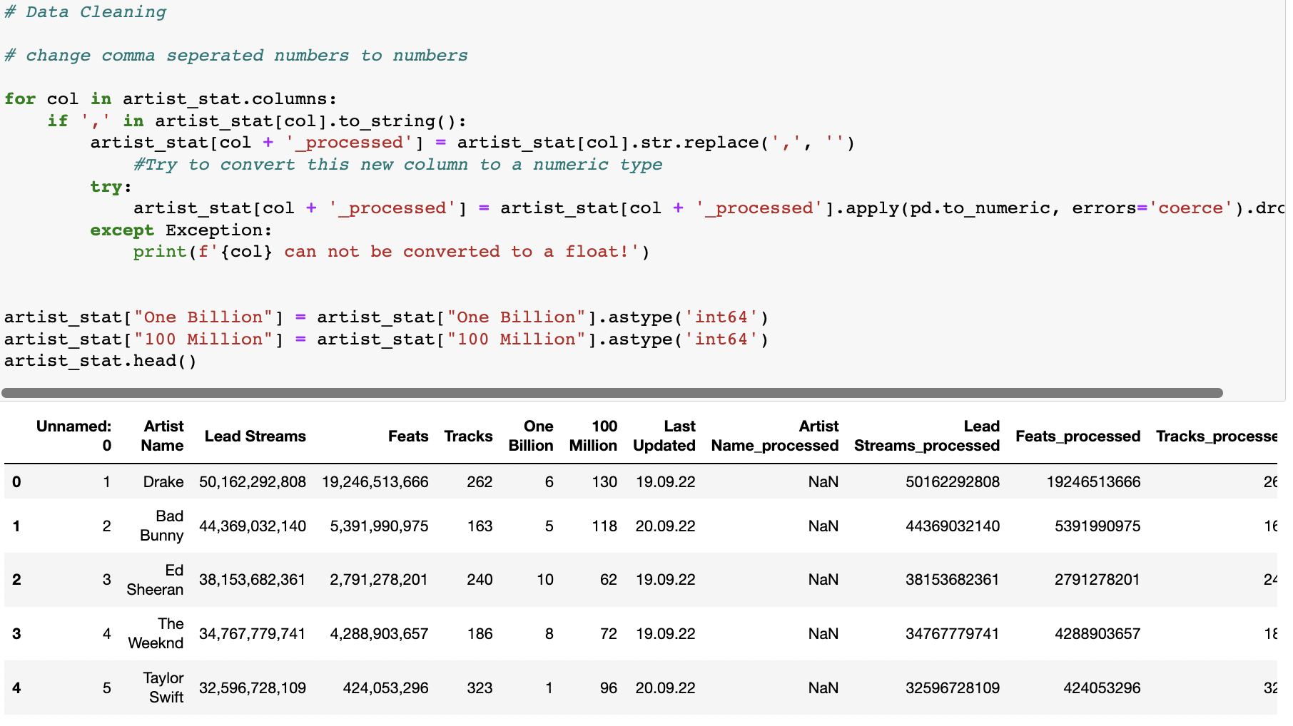

*Reasoning:*

After checking the default data types for this artist_stat file, we noticed pretty much all our data was appearing as python objects instead of an integers / float. Now we could have changed each element individually, but to simplify matters for the streams, features, and tracks’ columns (and to test our python development skills), we created a function that first, eliminates commas, then attempts to transform the subsequent data into a numeric object stored as a new column with a new tag ‘_processed.’ This worked as advertised for those three columns, and from there, we individually changed the One Billion and 100 million types to ‘int64’ using the astype function.

From there, all that is needed to clean up the artist_csv dataframe is to simply delete the undesired rows.

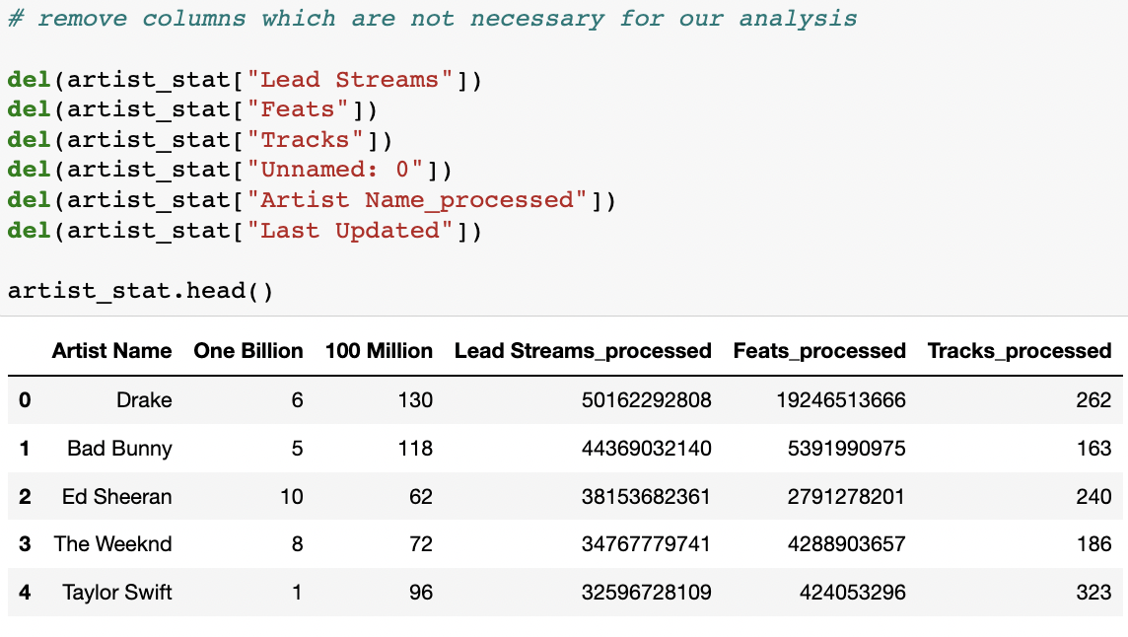

***Process 3: Merging files on artist name***

*Datasets: artist_stat and artist_spotify*

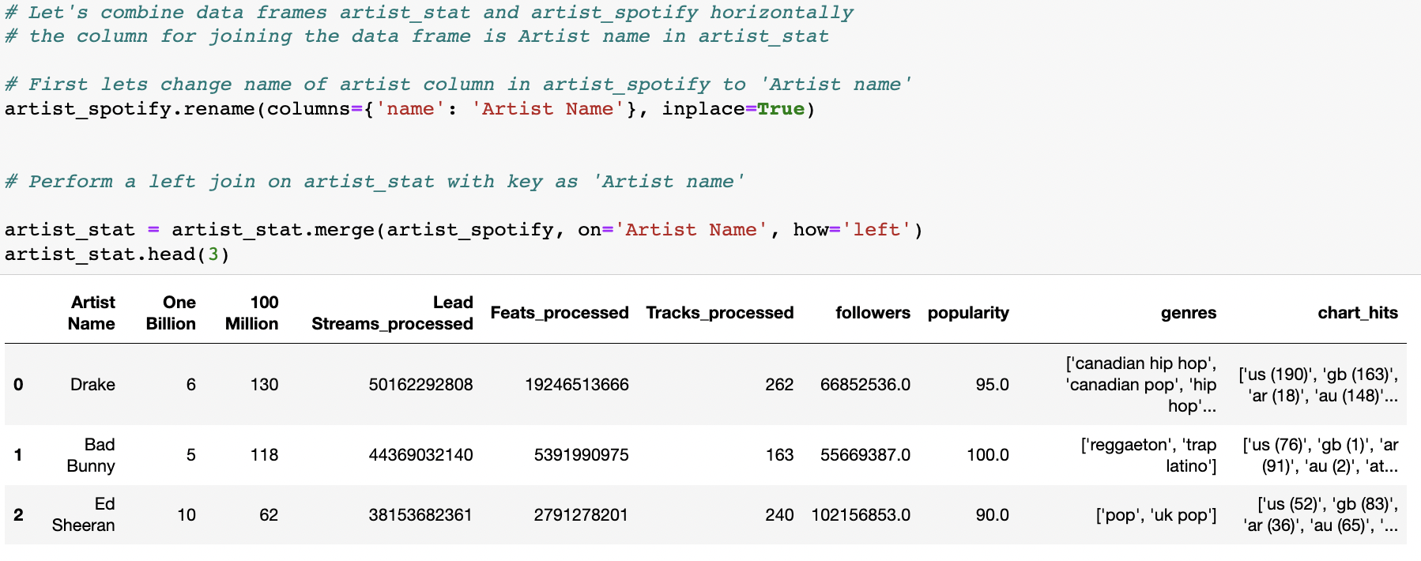

*Reasoning:*

Once the artist streaming csv was cleaned and ready to go, it was then time to look at the file containing other artist streaming information. Luckily, this one required little to no cleaning as all data was in the correct form. As such, we thought that concatenating these two files around artist name would make things easier upon getting to the analysis portion of the project. To combine files, we performed a left join and our artist_spotify data was added on the righthand portion of the artist_state data frame.

***Process 4: Creating new measure***

*Datasets: artist_stat (combined)*

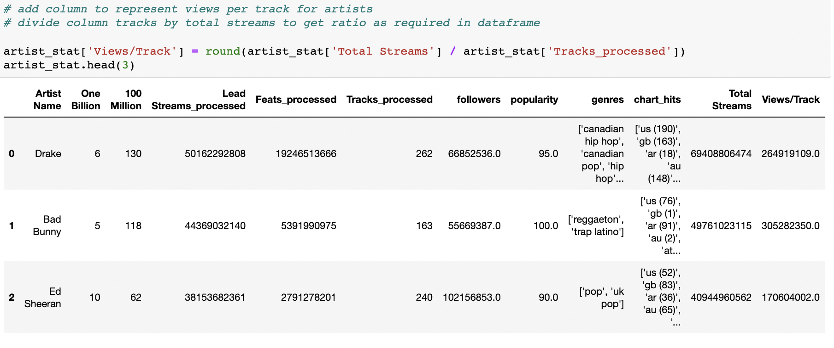

*Reasoning:*

In this new artist_state dataframe, we thought it made sense to include a manipulated column that puts our data in a potentially more interpretable form. With this mind, we divided tracks by total streams to create this ‘Views / Track’ column that adjusts our artist streams numbers in the context of the artists total number of songs. This will be a central piece of analysis in Q2 of this research project.

***Process 5: Eliminating second genre***

*Datasets: spotify_songs_data (combined)*

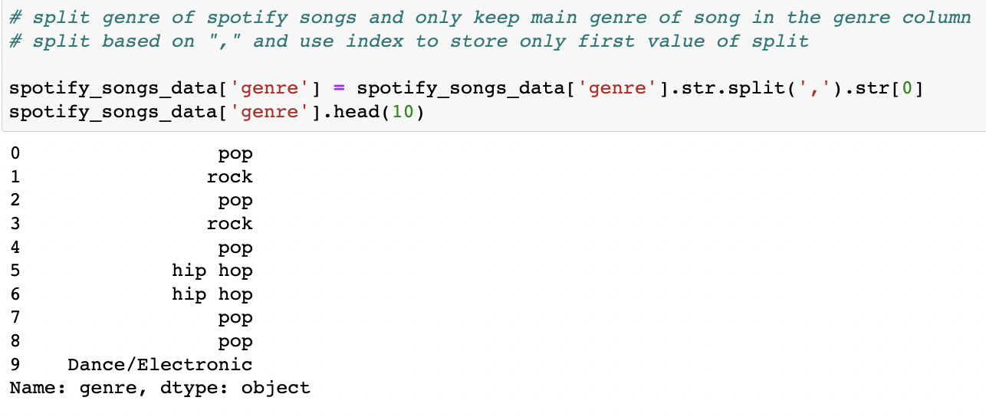

*Reasoning:*

In the genre column stemming from the Spotify top charts json file (spotify_songs_data), we noticed the genre column was naming multiple values. To account for this, we limited the column to only the first instance of genre (i.e the main genre type) by deleting everything following a comma. This was the final data cleaning method necessary.

**Exploratory Analysis:**

Before getting into specific research questions, we thought it best to get to know our data a bit more by looking at a few of our key factors at a high level. We began with a raw search of our top 2000 songs by genre and artist, followed up with visuals of these same measured plotted against the popularity score for that artist / genre. To add onto this initial research, we also looked at the possibility of a songs key influencing popularity patterns. Although we are not music experts, it is feasible to assume that a certain pitch or style of singing may be more popular than others. The visuals for that analysis show our top three artists (Drake, Rihanna, Eminen) with song measures by key and popularity.

*Popularity by Genre:*

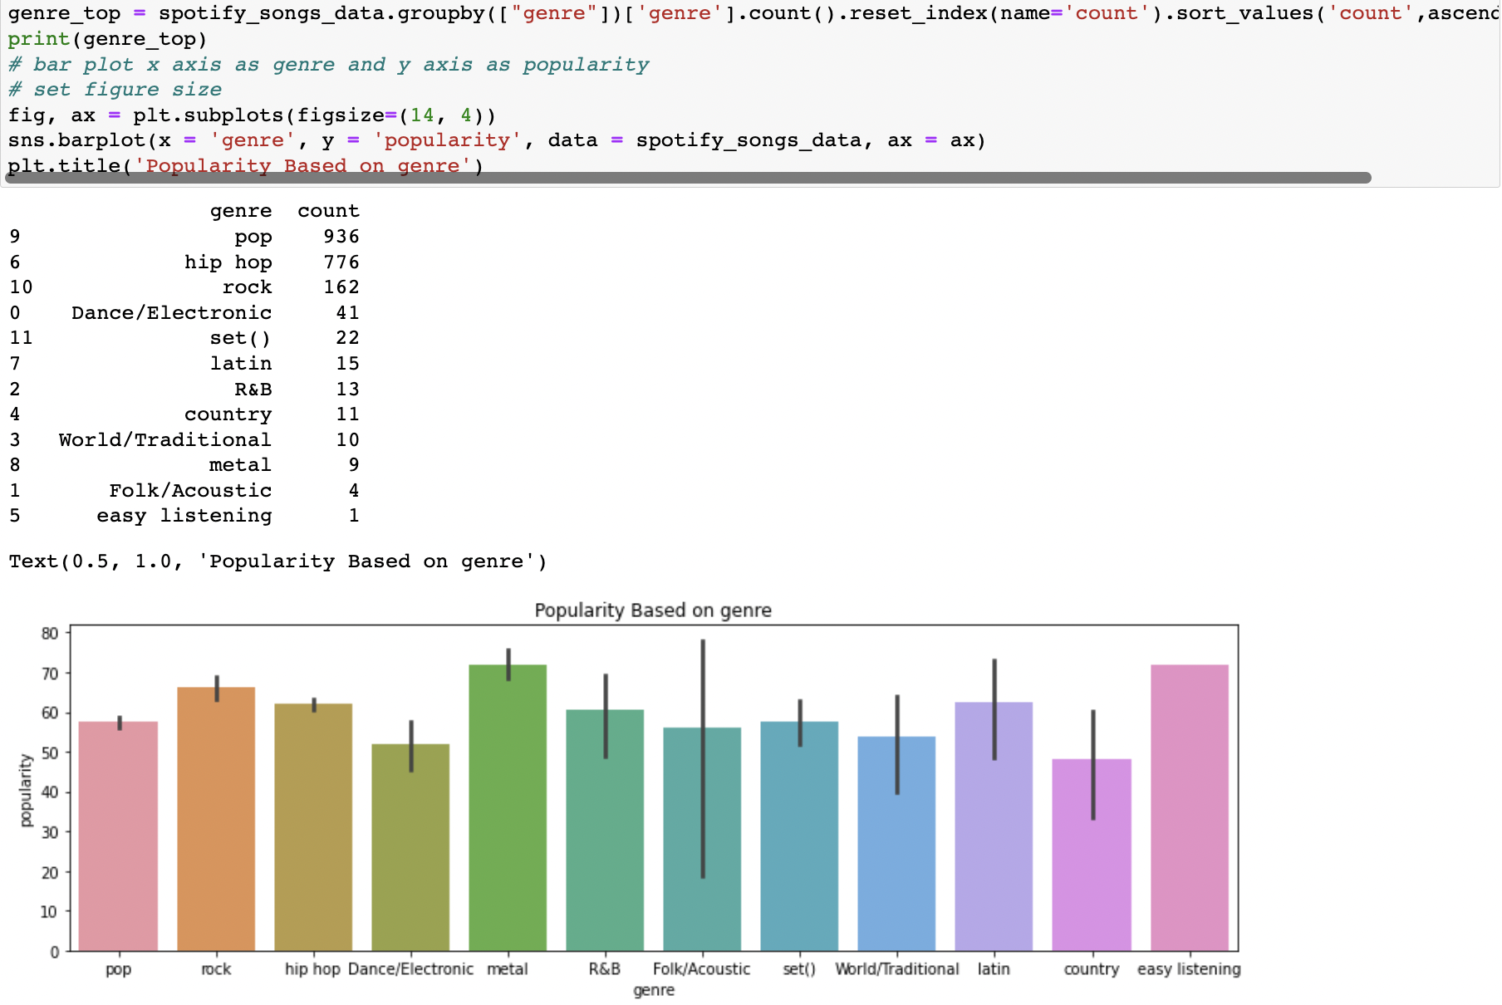

*Popularity by Artist:*

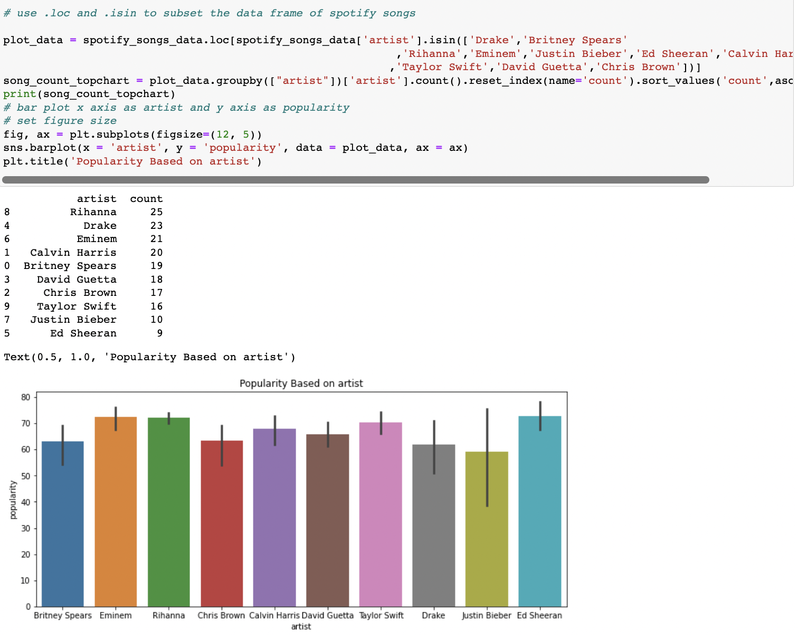

*Popularity by Key:*

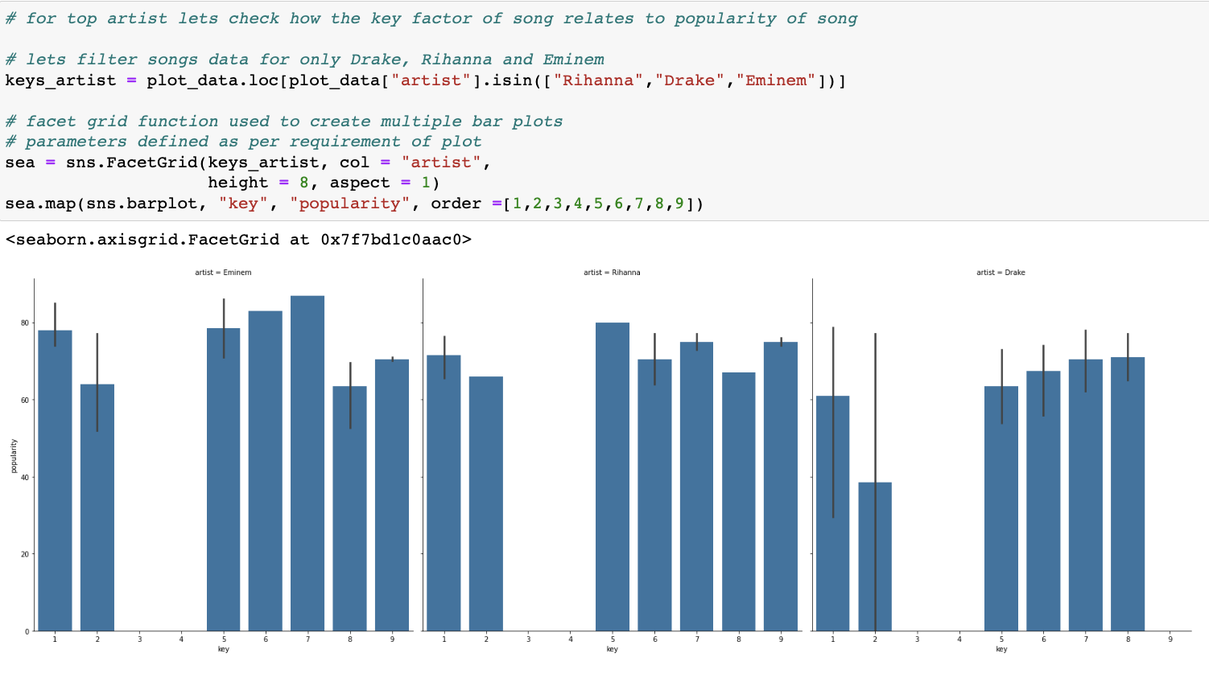

For genre, we see that hip hop and pop dominate the landscape of top chart songs; however, these songs do not always have a high popularity score across the board. In looking at the artist results, Rihanna and Drake have the high count of top songs with 25 and 23, but Ed Sheeran seems to have the highest popularity rating among these artists. For popularity by key, we were hoping to see some sort of relationship across the board for any of our artists, but it turns out that all of them vary in key to the extent where no conclusions can be made. While there is no concrete analysis that can be achieved from these counts and visuals, it is certainly a good starting place for our research questions.

*Correlation of Song Characteristics:*

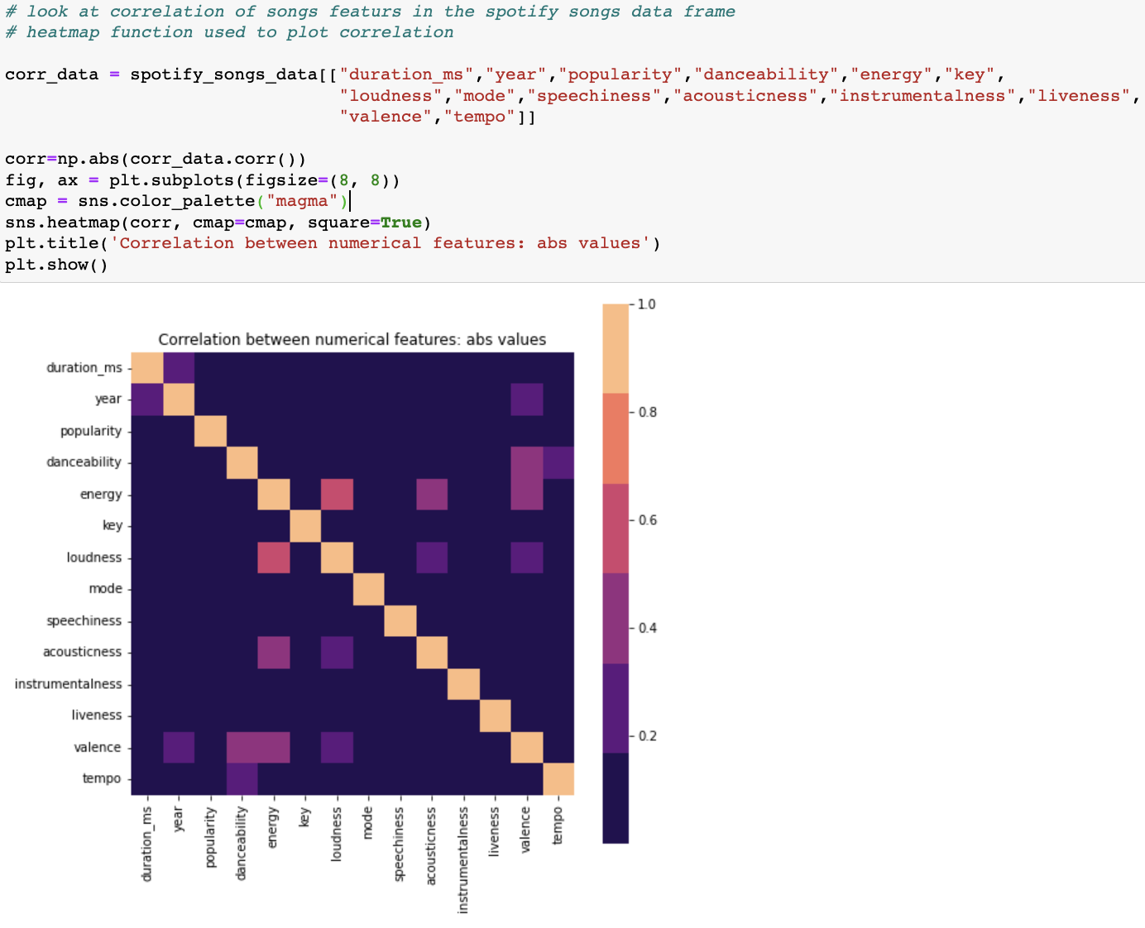

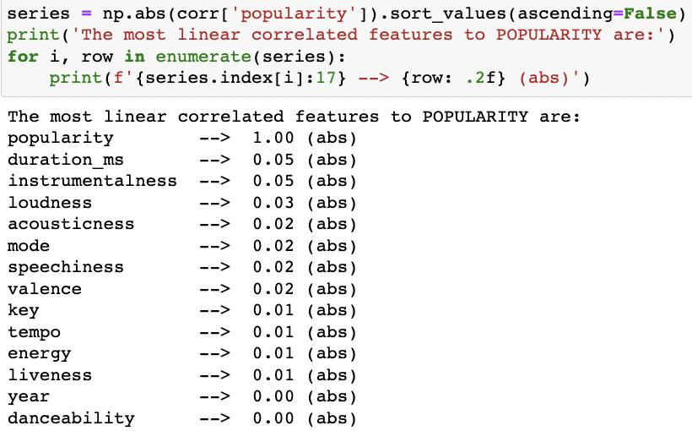

One final method of exploratory analysis we undertook was to cross reference each of our numerical features with each other using a correlation matrix, then measure those features in relation to song popularity. For the correlation portion, the goal here would be to find if any one feature is heavily linked to another, as this would allow us to narrow down potentially useful song characteristics. As you can see, not much can be gathered from the heatmap above as most items have a negligible correlation. For the popularity portion, the analysis is pretty much the same with no linear correlations above .05. As such, we can say the correlation between song characteristics and popularity is very weak.

**Research Questions and Analysis:**

Now that our data cleaning and exploratory analysis is over, it is now time to answer the main question of our analysis – Which artist has been the most dominant in the music industry over the past 20 years? At this point, we know enough about the data to perform concise analyses on each piece of data we’ve collected in hopes of gathering evidence in many contexts in support of a set of conclusions. To begin, let’s take look at how Drake, Ed Sheeran, Rihanna, and Enimem have fared year over year on the Spotify top charts.

**Q1: Performance of Top Artists by Year on Spotify Top Charts.**

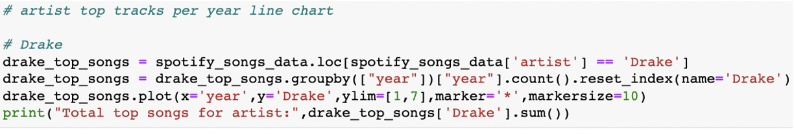

**Drake:**

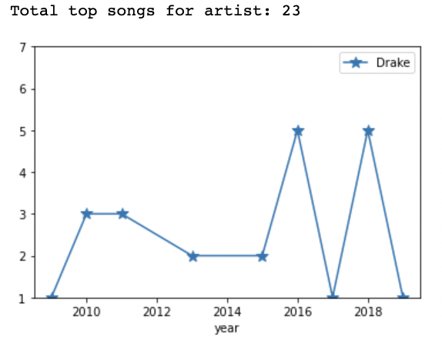

**Ed Sheeran:**

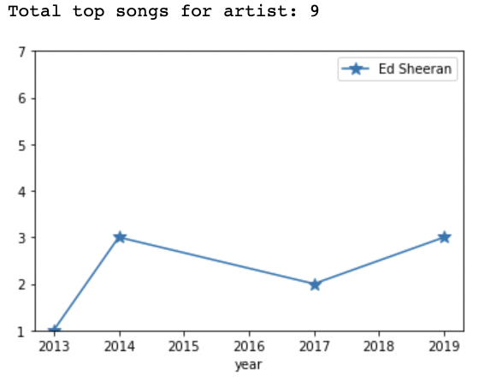

**Rihanna:**

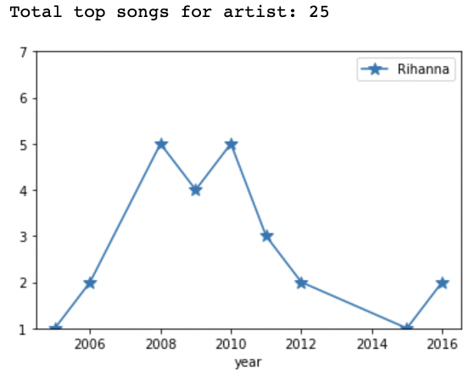

**Eminen:**

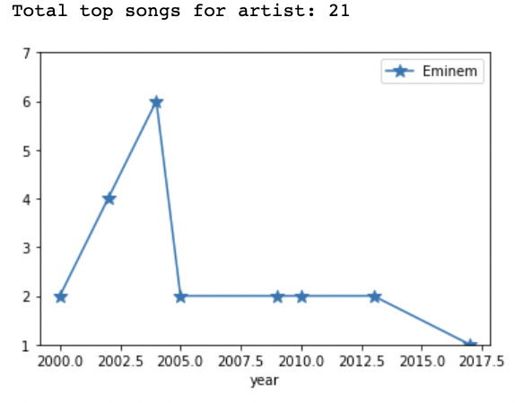

For background, we looked at these charts for the top 9 artists in terms of songs on the top charts, then narrowed it down to these four A-list artists for the time being. For Drake’s chart, there is a mix of some consistent presence with flashes of excellence in 2016 and 2018 when he had five top songs each. For Ed Sheeran, I’d characterize him more as a consistent artist who has not reached his peak yet. In the case of Rihanna, she is similar to Drake in that she had several dominant years (2007-2011) but has fallen off in recent years due to lack of production. And lastly, Eminen’s chart is probably the most unique out of them all, as he has been around for the longest time, while reaching a peak of 6 top chart songs in 2004. Based on these charts, a logical analysis would be that Drake, Rihanna, and Eminen all have a case to be the most dominant artist over this time period, while Ed Sheeran likely needs a few more years to reach his peak. Having said this, we of course understand that each top charted song is not the same, which is why we will investigate several specific metrics related to artist performance in the next section.

**Q2: Rankings by Streams, Followers, Popularity, Views / Track**

*Streams:*

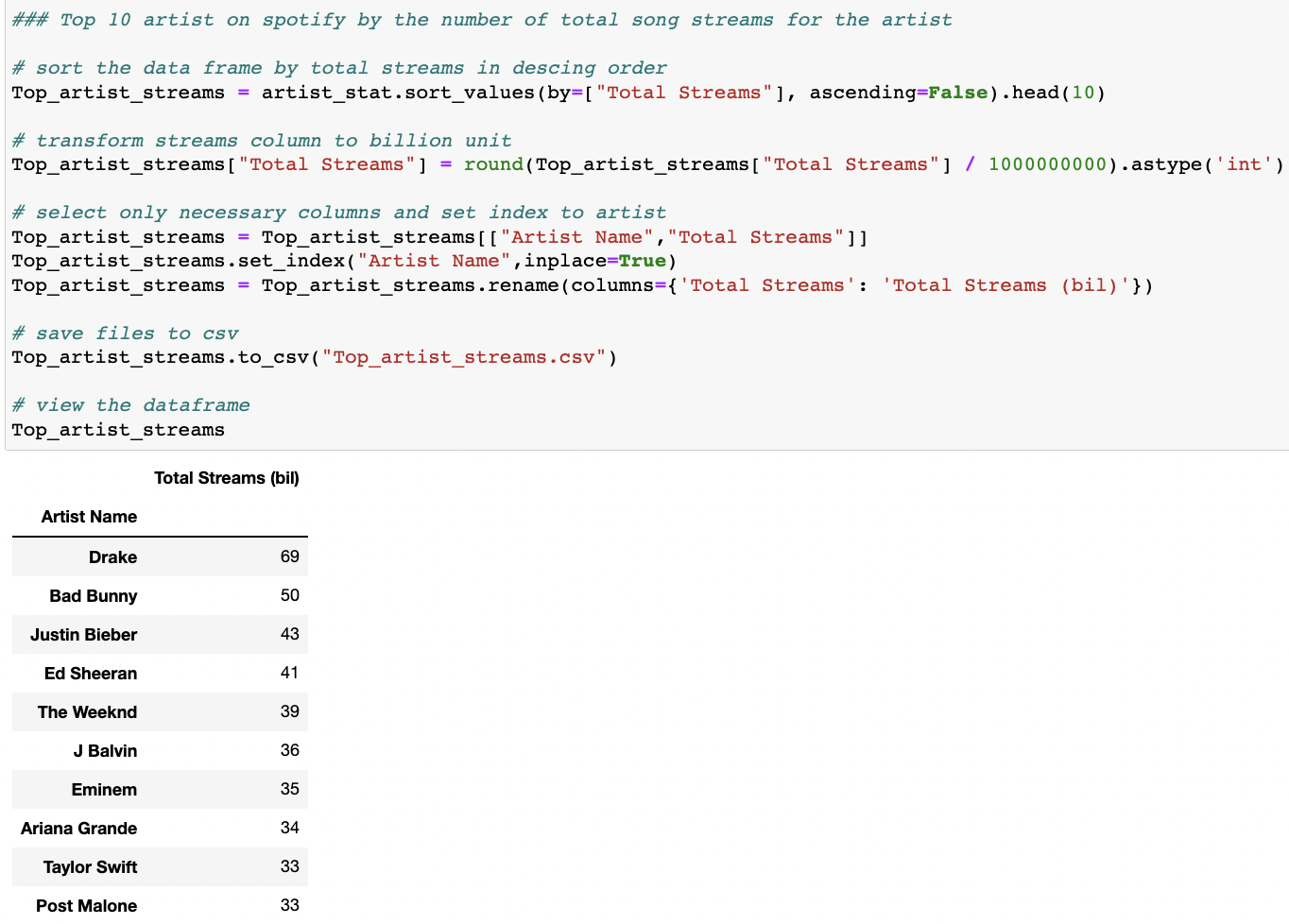

*Followers:*

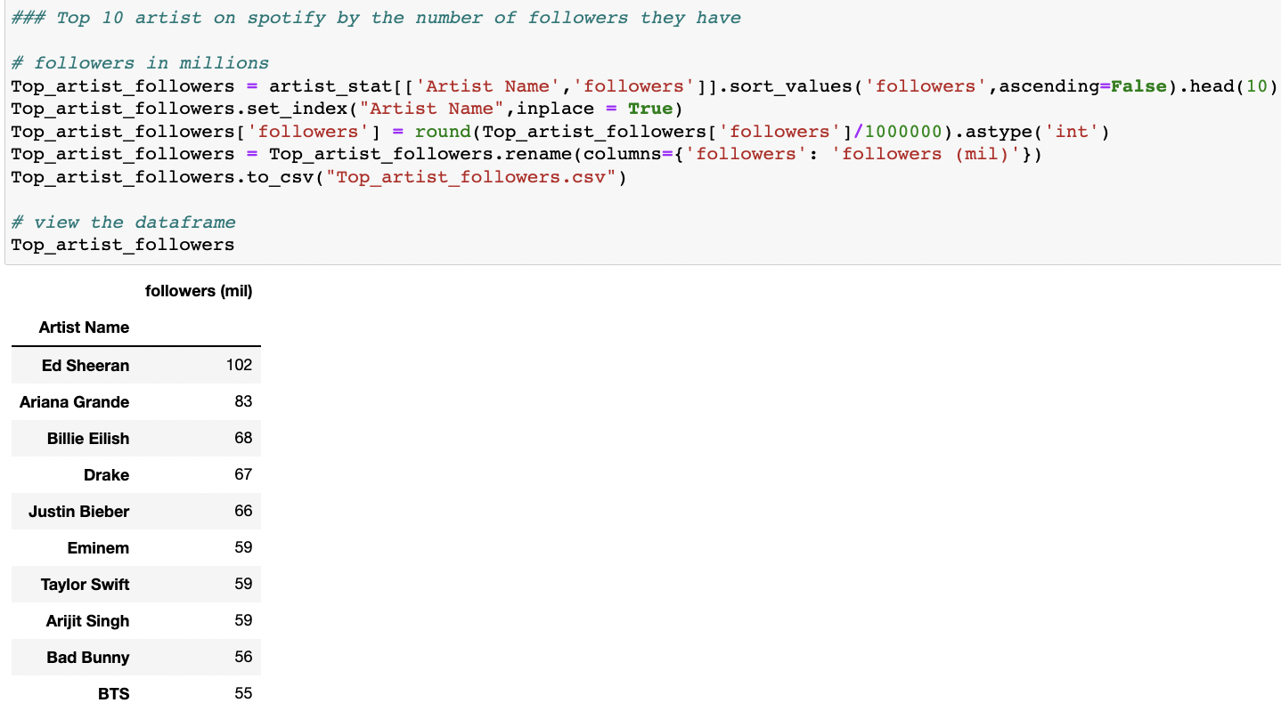

*Popularity:*

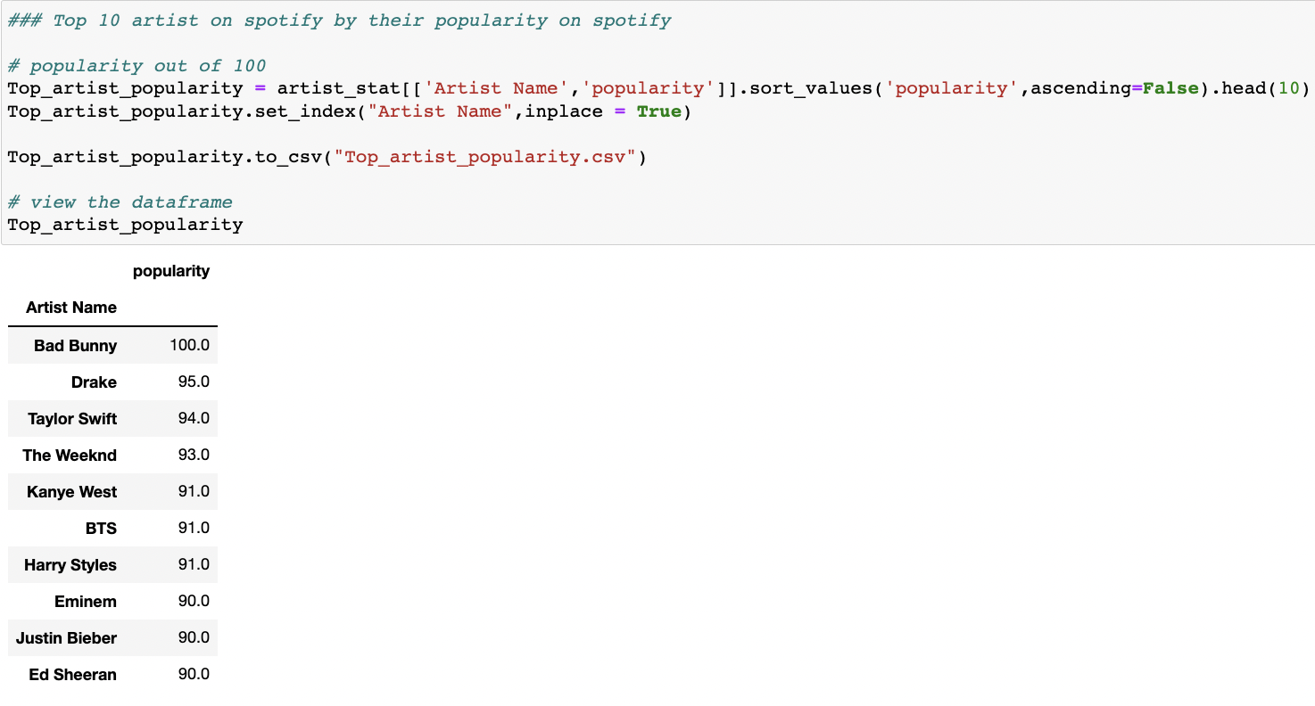

*Views Per Track:*

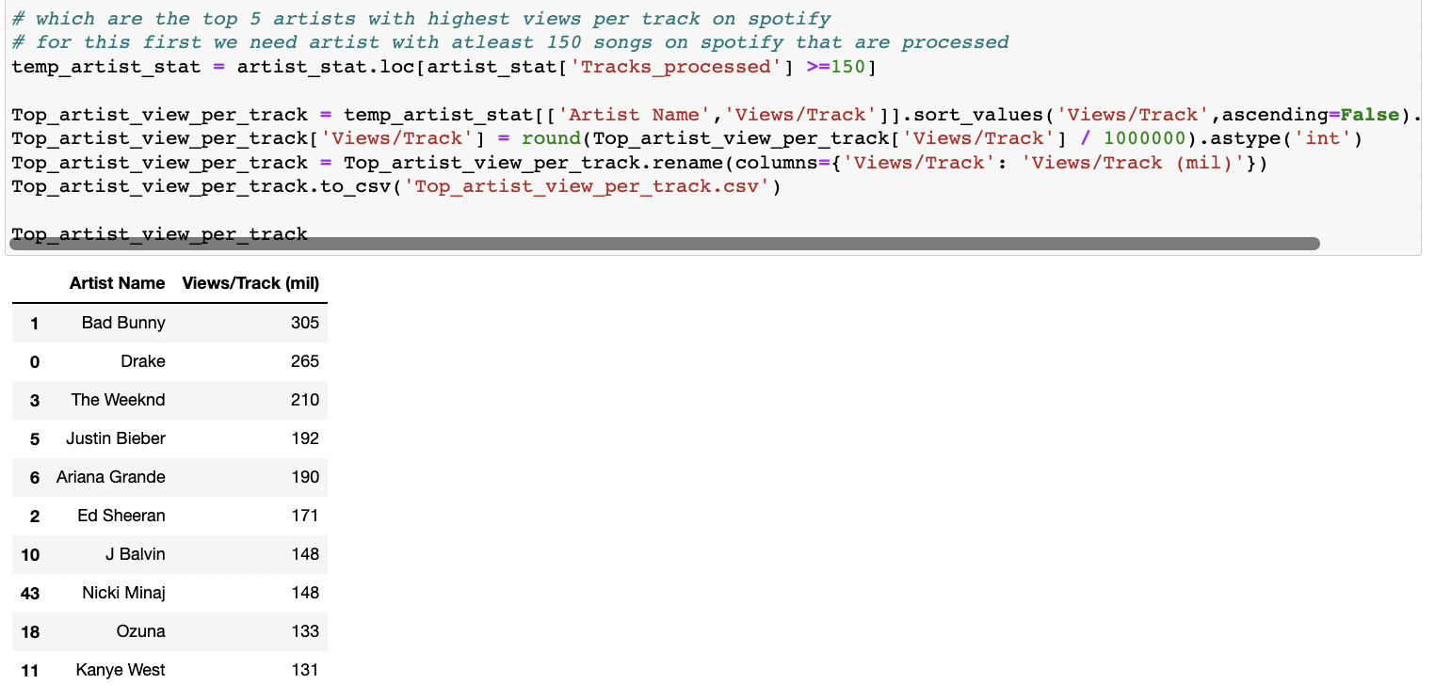

In this section, we thoroughly investigated the central key metrics in the artist_stat dataframe, in hopes of solidifying our research into the most dominant artist of the last 20 years. For each of the metrics shown above, we performed data manipulation tasks when needed before ultimately filtering out and sorting our desired column/s from largest to smallest. Upon performing this analysis, we gained a few key insights. For one, it was interesting to see Bad Bunny at the top of the list of views / track and artist popularity rankings. With a whopping 305 million views per track and a perfect 100 / 100 popularity rating, it is safe to assume that Bad Bunny has had one of if not the highest peak in terms of individual song success. He is someone that we had not considered in the previous analysis because of song quantity, but it’s clear that he deserves a mention based on the last few years alone. From there, we also noticed that Ed Sheeran has far and away the most followers with 102 million (35 million more than Drake), which suggests that he is having extreme success with new / younger fans, confirming our belief that he would project to dominate the next generation of Spotify popularity. Getting back to the artists with longer track records, Drake had by far the most total streams of Spotofy from 2000-2019 with a grand total of 69 billion. (yes, billion!). This is just about double the amount of Eminem (35 Billion). Drake also had a popularity rating of 95 and a Views / Track of 265 million (Both 2nd overall). Because we know these sample sizes to be quite substantial, these metrics very much support Drake’s case to be the most dominant artist in the time periods. As a final note on this analysis, Rihanna’s lack of songs over the last 5 or so years meant she was not a figure on either of these lists. While we have already acknowledged her greatness in that 2007-2011 window, her streaming numbers just can’t compete with the other names on this list.

**Q3: Artist and Genre Popularity by Year**

At this point, we have visualized, sorted, and grouped most of the pertinent variables used to figure out the most dominant artist over the past 20 years. With that in mind, we wanted to query a few more items to make sure we aren’t missing any key piece of information. To start, we went back and pulled the top chart artists by year.

*Songs by Year:*

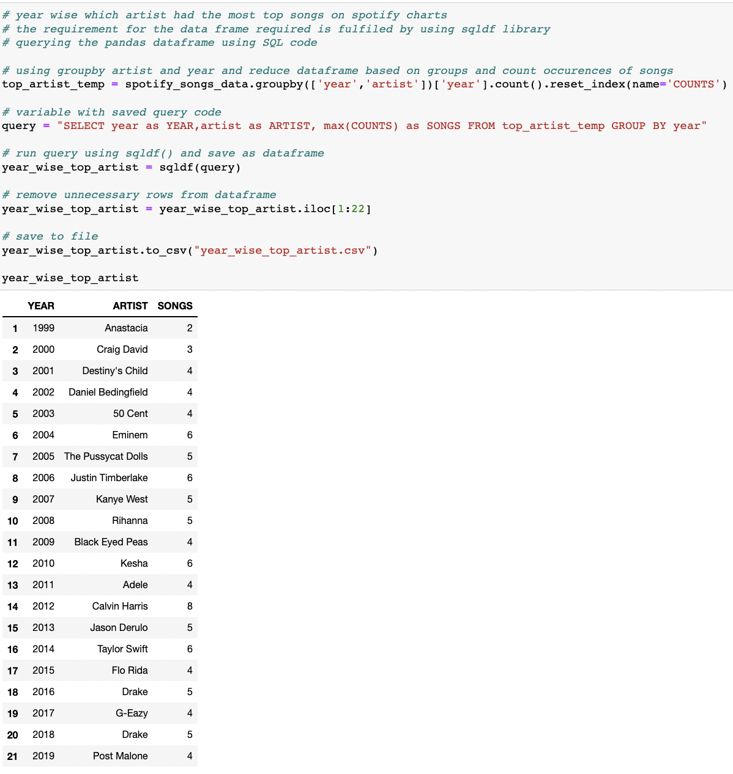

Although we already looked at similar pieces of information in the graphs in Q1, this SQL querying method gives us a second chance to look at all the names on the list once more in terms of presence on the top charts (Eminen with 6 in 2004, Rihanna with 5 in 2008 – confirms results from before).

*Song Genres by Year:*

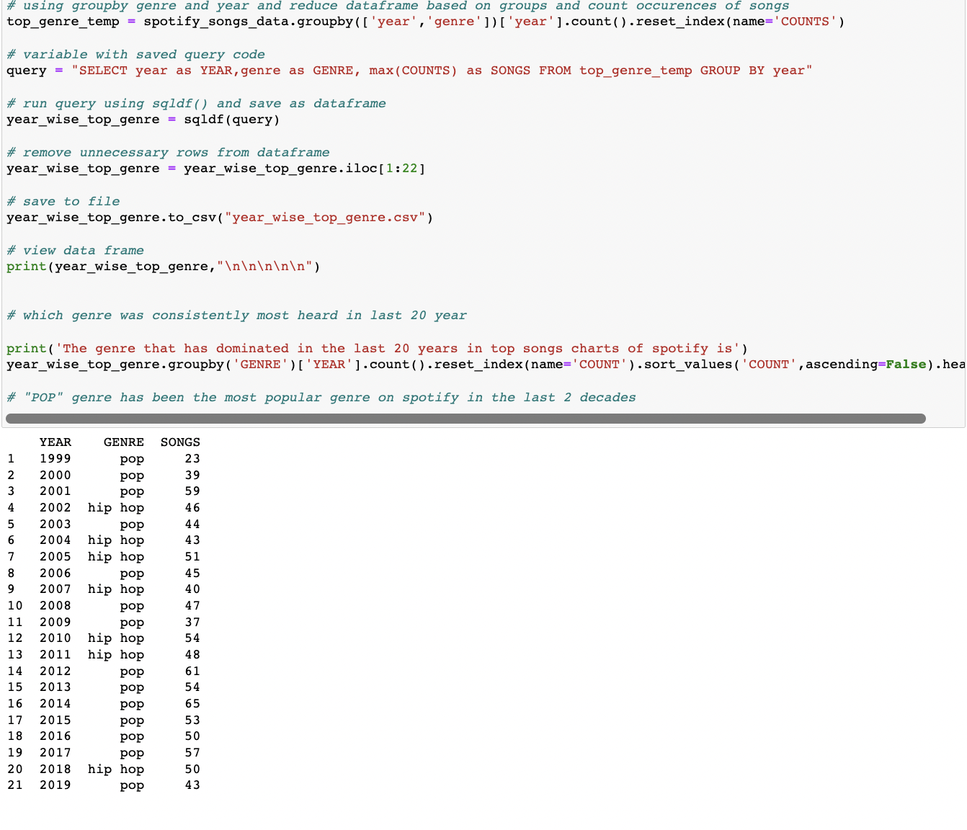

Because we were already working with the query code, we decided to group by and count by year in the context of top genre. We of course are not directly analyzing the top genre in this analysis, but a step such as this would be an important building block if we were to expand this research into the debate of hip hop vs. pop.

*Artist Most Mentions:*

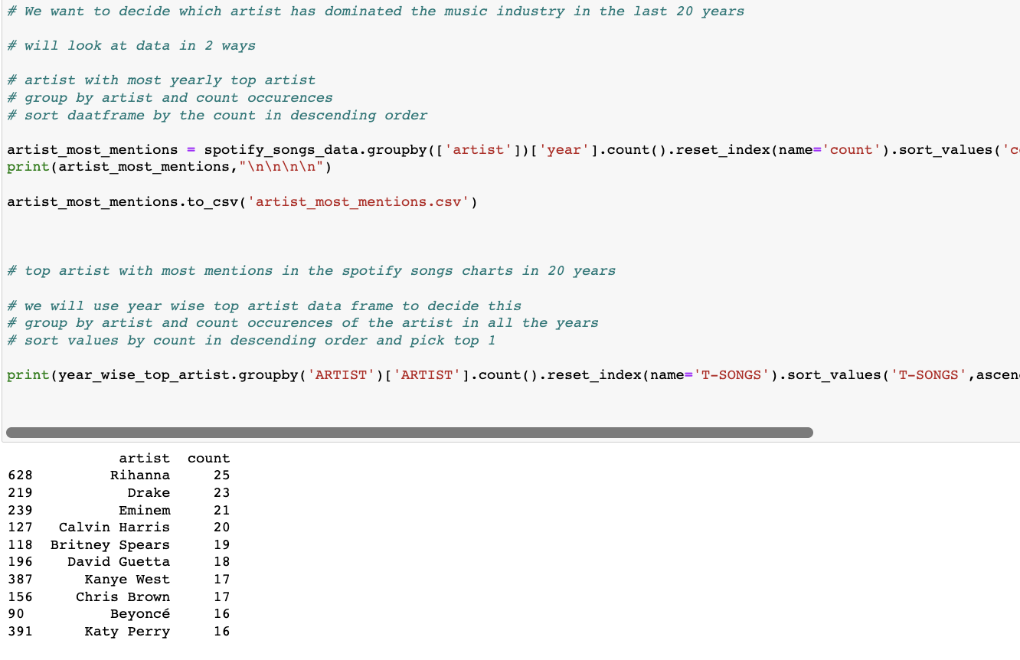

Moving on to the final piece of analysis used to directly answer our main research question, we wanted to configure the total number of songs in the top charts by artist overall. Yes, we could have counted each year individually dating back to the charts in Q1, but as we deal with more and more data, we see the need to automate these sorts of tasks using functions like group by, count, index, and sort values. In the end, we are left with a clean data frame of total songs on the top charts, with which we can see Rihanna, Drake, and Eminem on top.

*In our final program, you’ll see nltk experimentation with regards to song titles. Because that does not directly answer our research question, we have left it out of this report; however, we do find it very telling in many adjacent contexts.

**Conclusions:**

As the outline above hopefully makes clear, we were able to successfully combine multiple different data and sources in answering our research question – Who has been the most dominant artist of the past 20 years? While there is no absolutely definitely answer, our data analysis certainly leads us to believe that Drake is the most popular in most contexts. As evidence in our research, he has popularity rating of 95, a Views / Track of 265 million, and 23 total hits, all of which qualify as the second overall in their respective cateogires. While Eminem does have the best performing year (2004 with six hit songs), his raw metrics simply do not compare. Same goes with Rihanna, as she most definitely had a dominant period of 2007 – 2011 on her way to amassing a record 25 hit songs, but as of late, she has simply underperformed her fellow artists. From there, you might be asking yourself, what about Ed Sheeran and Bad Bunny? Well, if this was an analysis of the last five years or even a prediction about the generation, either of these options would be a great choice. However, when considering the entire time period, Drake is the clear number one choice!

**Tasks:**

-Researching Data Sources: Both Ben and Vaibhav

-Cleaning Data: Ben

-Forming Research Questions: Ben and Vaibhav

-Q1: Ben

-Q2: Vaibhav

-Q3: Vaibhav

-NLTK: Vaibhav

-Constructing a logical argument with our data: Ben and Vaibhav